***What is the valsalva manoeuvre?***

a forced expiration against a closed glottis after full inspiration, lasting 10 seconds at 40mmHg

***What are it’s applications?***

Assess autonomic function

Terminate SVT

***Describe the 4 phases of the manoeuvre?***

**phase1:**  At onset of expiration and is of short duration. Increased thoaco-abdominal pressures transiently increases venous return thereby raising BP and reflexly lowering HR

**phase2:** the sustained rise in intrathoracic pressure reduces venous return and so BP falls until a compensatory tachycardia restores it.

**phase3:** marks end of forced expiration and is of short duration. The release of pressure creates a large empty veneer reservoir causing BP to fall and the HR remains elevated.

**phase4:** the raised HR causes initially causes a raised BP as the venous return is restored. This is followed by a reflex bradycardia before both parameters return to normal.

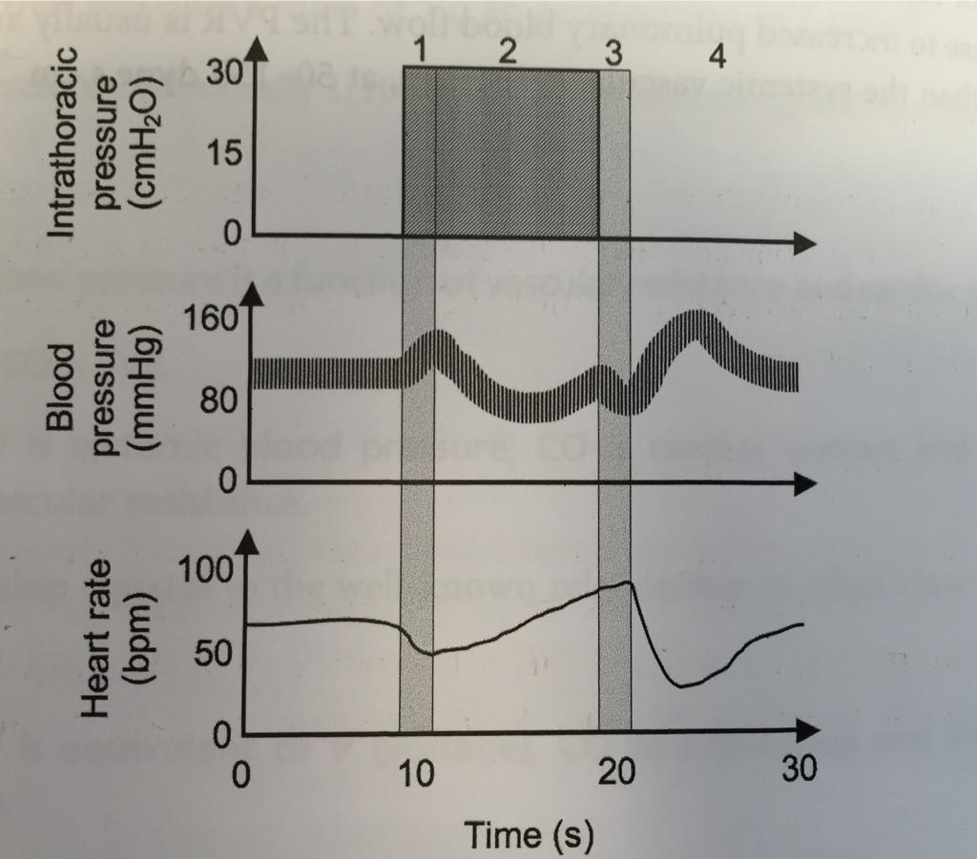

***How would the response differ in***

* ***diabetes (autonomic dysfunction)***
* ***heart failure***

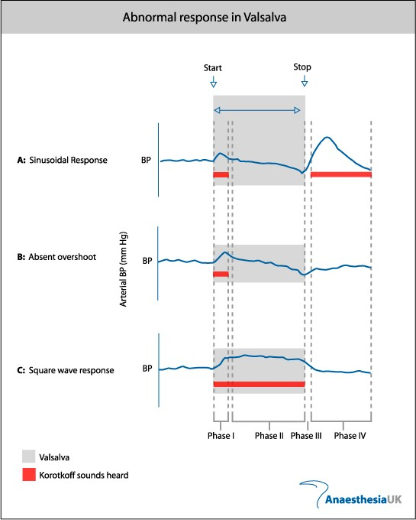

***[a: normal b: autonomic dysfunction c: heart failure]***

***How does the body sense acute changes in blood pressure?***

Baroreceptors sense change in BP. They are stretch receptors location in the walls of blood vessels and the heart and are stimulate by distension. As intra-luminal pressure increases the frequency of impulses discharged by the Baroreceptors increases. Baroreceptors also respond to the *rate of change* of intraluminal pressure. When stimulated the baroreceptors exert inhibitory signals to the vasomotor centres in the medulla causing bradycardia and vasodilatation.

High pressure baroreceptors are located in Aortic arch and Carotid sinus (more sensitive). Signals are transmitted via the Vagus nerve for AA baroreceptors and the Glossopharyngeal nerve for CS baroreceptors. [Rapid short term BP control]

Low pressure baroreceptors are located in chambers of heart, large systemic veins and pulmonary vasculature. [Slower, sustained BP control]

***What physiological response to acute loss of 2 Litres of Blood?***

There are Cardiovascular, neurohumoral and renal compensatory mechanisms.

i) Immediate Baroreceptor response:

High pressure (A.A/C.S) baroreceptors have reduced stretch therefore have reduced firing of inhibitory afferents to Cn.10/9. Therefore increased Sympathetic outflow causing Tachycardia and vasoconstriction/SVR and increased isotropy.

ii) Redistribution of cardiac output; vasoconstriction diverts blood flow from skin and muscles to the brain and heart.

iii) Recruitment;

1- HPA axis detects low blood volume and releases ADH from Posterior Pituitary to help conserve water.

2- RAAS activation; fall in renal blood flow detected by JGA leads to Angiotensin2 which directly causes vasoconstriction and releases Aldosterone.

3- Translocation of fluid from ISF via Starling’s forces; due to fall in intravascular hydrostatic pressures and rise in in oncotic pressure.Volume= 0.25mls/kg/minute